Parth Babbar

Credit reporting agencies and credit reports, Credit card underwriting and issuance & Credit card processing and payment networks

Credit Reporting Agencies and Credit Reports:
Credit reporting agencies (CRAs) are corporations that collect and store consumer credit data. Equifax, Experian, and TransUnion are the three credit reporting agencies in the United States. They give credit reports that contain a history of an individual's credit behaviour as well as current credit status, such as loans, credit cards, and payment histories.
Function:
- Data Collection: The CRA compiles credit reports from a variety of sources. They get information from lenders on credit accounts, payment history, limits, and balances, as well as public data such as bankruptcies and liens. Data from collection agencies on accounts sent to collections is also included, ensuring that CRAs offer correct credit reports.
- Credit Reports: The CRA compiles credit reports that summarize an individual's credit history. These include personal information (name, address, Social Security number, date of birth), credit accounts (credit cards, mortgages, auto loans, personal loans), credit inquiries, and public records (bankruptcies, tax liens, collection accounts).
- Credit Scores: CRA frequently issue credit scores, which are numerical representations of an individual's creditworthiness. Common models include the FICO Score (300 to 850) and the VantageScore, which has a comparable range.
Importance:
- Lenders: Credit reports are used to assess the risk of lending to individuals and set terms like interest rates and credit limitations.
- Companies: Some companies check credit records as part of the employment process, especially for positions with financial responsibility.
- Consumers: Can review their credit reports to better understand their credit position, identify problems, and take measures to improve their credit scores.
Challenges:
- Accuracy: Errors in credit reports can have a major impact on customers' ability to acquire credit. Common inaccuracies include wrong personal information, improper account statuses, and incorrect public data.
- Privacy: Protecting sensitive customer information from breaches and unauthorized access is a top priority. High-profile data breaches, such as the Equifax hack in 2017, compromised the personal information of millions of customers.
- Access and Fairness: Ensure that all consumers have equal access to credit reporting and that reports do not unjustly disfavour specific groups. Studies have indicated that minority populations frequently encounter discrepancies in credit reporting and ratings.
Solutions:
- Regulations: Strengthened enforcement of the Fair Credit Reporting Act (FCRA) to safeguard credit report accuracy and privacy. The FCRA requires CRAs to investigate and repair mistakes in credit reports within 30 days of a consumer dispute.
- Technology: Using sophisticated algorithms and artificial intelligence (AI) to detect and repair faults more effectively. Machine learning models may detect and correct flaws in huge datasets.
- Consumer Education: Programs that teach consumers about their FCRA rights, how to preserve excellent credit, and how to contest inaccuracies on their credit report. Organizations such as the Consumer Financial Protection Bureau (CFPB) provide materials and tools to help individuals understand and manage their credit.
Statistics:
- Market Size: In 2022, the credit reporting market was valued at $12 billion. By 2032, the worldwide market is expected to grow at a CAGR of 4.8% to US$ 28.47 billion.
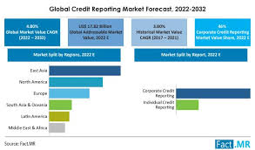
- Consumer Access: The major credit reporting agencies (CRAs) store credit information for over 200 million Americans.
- Disputes: The Consumer Financial Protection Bureau (CFPB) gets tens of thousands of complaints each year about credit report mistakes. In 2022, the CFPB handled around 300,000 consumer complaints concerning credit reporting.
- Credit Scores: The average FICO score in the United States hit 716 in 2022, a record high.
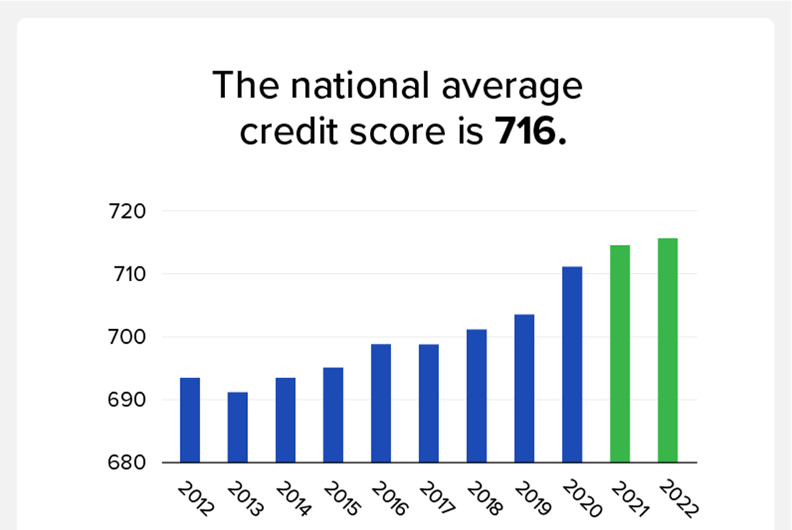
Conclusion:
Credit reporting agencies (CRAs) are critical for ensuring the accuracy of consumer credit information and providing lenders with trustworthy data to determine creditworthiness. Despite their critical significance, issues such as accuracy, privacy, and fairness continue. Enhanced governmental control, technology advances in data management, and increased consumer education are critical to tackling these concerns. By verifying accuracy, preserving privacy, and promoting justice, CRAs can help to maintain fair and accessible credit markets in the United States.
Credit Card Underwriting and Issuance:
Credit card underwriting is the process by which issuers assess the risk of issuing a credit card to a customer. This includes evaluating the applicant's creditworthiness, income, and other characteristics to establish their capacity to return the borrowed monies. The issue procedure consists of approving the application, establishing credit limits, and giving the actual card.
Steps:
- Application Submission: When consumers apply for credit cards, they provide personal information, financial information, and, in certain cases, extra verification.
- Credit Assessment: Issuers consider credit reports and ratings, income, job status, debt-to-income ratio, and other relevant variables. Advanced analytics and machine learning models are increasingly being employed to improve credit assessment.
- Decision Making: Based on the review, issuers determine whether to approve or refuse the application. If authorized, they will also set the credit limit and interest rate based on the applicant's risk profile.
- Approval and Issuance: Approved applicants receive credit cards with terms and conditions that include interest rates, fees, and rewards programs.
- Activation: Customers activate their cards, generally via phone or online, and may then use them to make purchases.
Issuance Process:
- Approval: Once an application is authorized, the issuer creates the credit card and sets the credit limit.
- Card Production: A real card is created and personalized with the cardholder's name, account number, and expiration date.
- Distribution: The card is shipped to the cardholder, together with activation instructions and a copy of the Terms and Conditions.
- Activation: The cardholder activates the card via a secure process that may include identity verification.
Challenges:
- Risk management: Entails accurately calculating the risk of default and determining suitable loan limits and interest rates. Default rates can be influenced by economic downturns and shifts in consumer behaviour.
- Regulatory Compliance: Complying with rules such as the Credit Card Accountability, Responsibility, and Disclosure (CARD) Act, which seeks to safeguard customers from unfair activities.
- Fraud Prevention: Preventing identity theft, application fraud, and account takeovers. Fraudulent operations cost issuers billions of dollars every year.
Solutions:
- Advanced Analytics: The application of machine learning and big data analytics to enhance risk assessment and underwriting accuracy. Predictive models may use massive volumes of data to identify possible problems.
- Regulatory Frameworks: Programs designed to assure regulatory compliance and reduce legal risks. Policies must be monitored and updated on a regular basis to ensure compliance with changing legislation.
- Security Measures: Fraud prevention measures include enhanced security procedures and technology such as EMV chip cards, tokenization, and biometric authentication. Multi-factor authentication and real-time transaction monitoring can also assist detect and prevent fraudulent activity.
Statistics:
- Credit Card Ownership: Approximately 70% of Americans have at least one credit card, with an average of 3.1 cards per cardholder.
- Approval Rates: Between 40 and 50% of credit card applications are accepted. Approval rates vary greatly depending on the applicant's credit profile.
- Outstanding Credit: In 2024, the US had around $1.12 trillion in outstanding credit card debt. The average credit card balance per household was about $6,218.
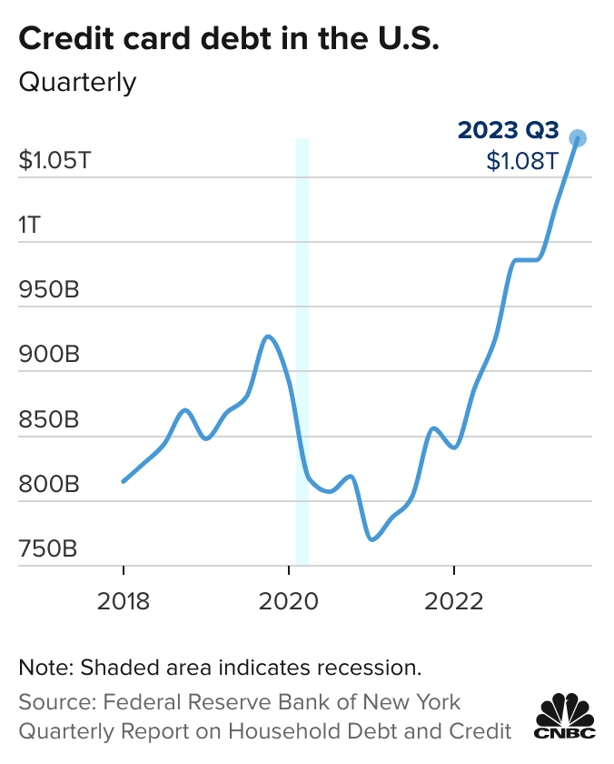
- Interest Rates: In February 2024, credit cards had an average annual percentage rate (APR) of around 22.63%.
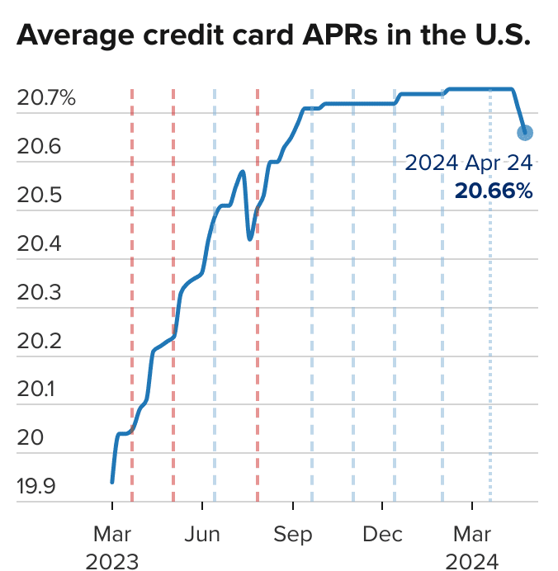
Conclusion:
Credit card underwriting and issuance are complex operations that entail assessing risk, establishing credit limits, and providing cards to customers. The industry has issues in risk management, regulatory compliance, and fraud prevention. Using modern analytics to improve risk assessment, adhering to tight regulatory frameworks, and implementing strong security measures are all key answers. These actions not only reduce risks, but also boost customer trust and encourage responsible credit card use in the US financial environment.
Credit Card Processing and Payment Networks:
Credit card processing refers to the procedures and systems required to execute credit card transactions. Payment networks make these transactions easier by serving as middlemen between card issuers and retailers. The primary payment networks in the United States include Visa, MasterCard, American Express, and Discover.
Key Players:
- Issuers: Banks and financial firms providing credit cards to customers. They offer credit and maintain cardholder accounts.
- Acquirers: Banks and financial organizations that accept credit card payments from retailers. They make it easier to accept credit card payments.
- Payment Networks: Companies that offer the infrastructure and procedures for handling card transactions. They guarantee that transactions are performed safely and effectively.
Processing Steps:
- Authorization: The cardholder begins the transaction by showing their card to the merchant. The merchant's point-of-sale (POS) system transmits an authorization request to the acquirer, who transfers it to the payment network. The payment network sends the request to the issuer for approval.
- Authentication: The issuer confirms the cardholder's identification and determines the availability of money or credit. The issuer accepts or refuses the transaction, and the response is routed back through the payment network to the acquirer and eventually the merchant.
- Clearing and Settlement: Approved transactions are batch processed and delivered to the acquirer for clearance. The acquirer provides the transaction information to the payment network, which then transfers it to the issuer. The issuer sends funds to the payment network, which rewards the acquirer. Finally, the acquirer transfers monies to the merchant's account, less fees.
Challenges:
- Security: Ensuring secure transactions while safeguarding against data breaches and fraud. The growth in cyber threats and advanced hacking tactics creates continual hazards.
- Interchange costs: The high costs that retailers must pay to execute transactions can be expensive, particularly for small firms. These fees represent a considerable expense component for retailers.
- Technological Integration: Integrating new payment technology into existing systems. The fast growth of payment technologies, such as contactless payments and digital wallets, need ongoing infrastructure upgrades.
Solutions:
- EMV Technology: Use of chip cards for increased security. EMV (Europay, MasterCard, and Visa) technology outperforms magnetic stripe cards in terms of counterfeit fraud prevention.
- Regulatory Efforts: Efforts to control and limit interchange fees. The Durbin Amendment, part of the Dodd-Frank Act, sought to lower debit card interchange costs. Similar techniques for credit cards might help merchants save costs.
- Innovations: Creation of new technologies such as contactless payments, digital wallets, and blockchain to provide safe and efficient processing. These improvements have the potential to speed up transactions, make them more convenient, and increase security.
- Enhanced Fraud Detection: The use of enhanced fraud detection systems that employ machine learning and artificial intelligence to detect and prevent fraudulent transactions in real time. These systems may evaluate transaction trends and identify abnormalities that could suggest fraud.
Statistics:
- Transaction Volume: In 2023, the US handled more than $6 trillion in credit card transactions. The volume of transactions exceeds 100 billion.
- Payment Network Market Share: Visa and MasterCard control over 80% of the market, with Visa having the greatest share. American Express and Discover both have a considerable market presence.
- Transaction Fees: The typical interchange charge is between 1.8% and 2.5% every transaction. Total merchant fees, which include interchange, assessment, and processing costs, vary but commonly fall between 2% and 3%.
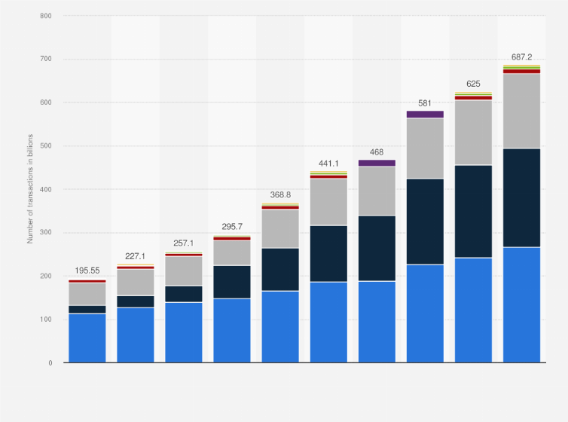
Conclusion:
Credit card processing and payment networks are critical in ensuring safe and efficient transactions between customers, retailers, and financial institutions. Security risks, hefty interchange fees, and technology integration are all challenges that must be addressed together. Implementing modern security technology, campaigning for legislative reforms to regulate costs, and adopting new payment methods are critical options. Payment networks can provide smooth and dependable payment experiences for stakeholders throughout the US economy by improving security, lowering costs, and embracing innovation.
Conclusion:
Credit reporting agencies, credit card underwriting and issuance, and credit card processing and payment networks are all critical components of the US financial system. Each industry has distinct obstacles while also providing significant chances for innovation and progress. These industries can better serve customers and companies by utilizing technology, strengthening regulations, and increasing consumer education.

